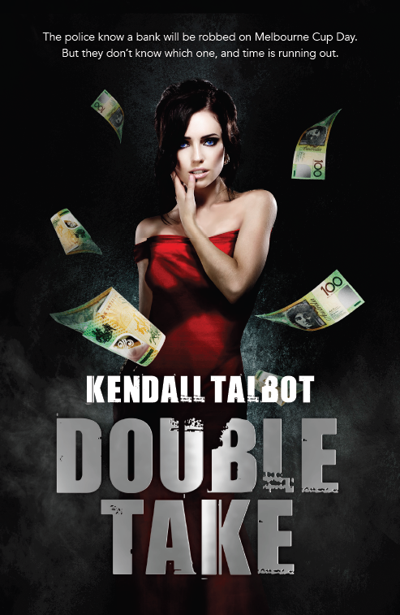
Publication Date: September 2015
RRP AU$29.99 / RRP NZ$33.99

DOUBLE TAKE

KENDALL TALBOT

*Australian author available for interview*

With all the twists of a Tarantino plot and gritty Aussie humour reminiscent of the 1990 thriller/comedy ‘Two Hands’, this crime caper is set to be an Australian Classic…

DOUBLE TAKE is Award-winning author Kendall Talbot’s first furor into crime fiction and she wastes no time in asking the big questions – would you commit a felony for the person you love? And, does crime really pay?

The inspiration for this page-turning thriller was born when the bank that author Kendall Talbot worked in on Eagle St, Brisbane, was robbed. Although she wasn’t there at the time, she remembers thinking “if I was to rob a bank I’d probably rob this one.” It happened in 1992, the same year in which DOUBLE TAKE is set, before mobile phones, protective booth screens, and well before state-of-the-art security.

Talbot has used her knowledge of the bank and the robbery to bring this story to life and has added further intrigue by setting the heist on Melbourne Cup Day, when the nation notoriously stops for the running of the big race and when tellers, customers, even the bank’s security are distracted.

DOUBLE TAKE takes readers on a spellbinding journey of surprising twists and turns as the past and the present catches up with protagonist, Jackson Rich, a name that holds much irony for a man who is anything but, or is he.

About DOUBLE TAKE

Jackson Rich is an unlucky man – he’s lost his job, his house and it looks like he’s going to lose the love of his life. To buy his terminally ill wife Candice more time, he’ll try just about anything. Including robbing a bank, on the one day of the year everything shuts down: Melbourne Cup day.

To do it, Jack has to call in a promise from his old gang. It’s been a long time since they were all together, but they would do anything for him – at least that’s what he’s banking on. Nothing could possibly go wrong. Until a couple of kids overhear Jack and his gang planning the robbery, that is.

Even after thirty-odd years as a cop Detective Steel has never been presented with a scenario like this, but he has to act upon the tip-off he’s been given. Somewhere in Brisbane, sometime during the running of the 1992 Melbourne Cup, a bank is going to be robbed. But to catch the thieves, Steel must let the heist happen. He’s about to make the quickest bust in history. What could possibly go wrong?

About Kendall Talbot

Kendall Talbot is an Australian award-winning author of romantic suspense crime who exploded onto the writer’s scene with her debut novel Lost in Kakadu. After being nominated for a clutch of awards, the book took out the prestigious RUBY Romantic Book of the Year 2014 award.

Residing in Brisbane with her husband, two grown sons and fluffy little dog, Josie McLuvin, she has a passion for travelling and has visited some 36 countries. Her novels and blog writings have always been reflective of her life experiences, based on her hunger for thrill and adrenalin and the love affair she has with her very own hero.

To read more about Kendall and her work, visit her website at: www.kendalltalbot.com.au ,
follow her tweets on @kendallbooks or check out her Facebook page: www.facebook.com/KendallTalbotBooks

Interviews and extracts are available on request.

For more information or interview requests please contact Nikki Wirkerman nikki@moreymedia.com.au or Zoe Warden zoe@moreymedia.com.au or
call morey media on (02) 9954 7955.

